- Double click on the Licence Key Wizard to open
- Select Obtain or manually add another key
- Click Next
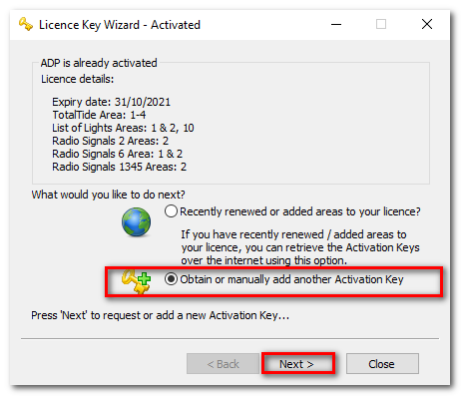
- Under Installed keys click the Select a key drop down
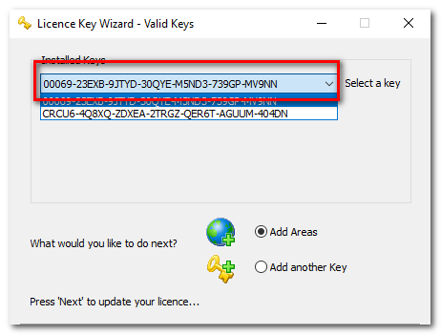
- Select the Key(s) and this will show if it’s an Activation or Start Up Key
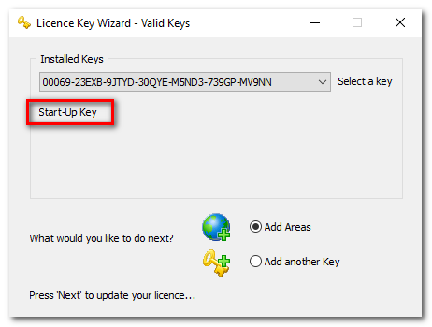

- Check the Start Up Key is the correct Start Up Key for your licence against the email you received when you purchased the licence (or check this with your ADMIRALTY Chart Agent who can confirm)

