Users can request the AVCS ENC data (Excluding AIO) for up to 250 ENCs via the Exchange Set function within the File Share Service (FSS) site

<https://fss.admiralty.co.uk/>

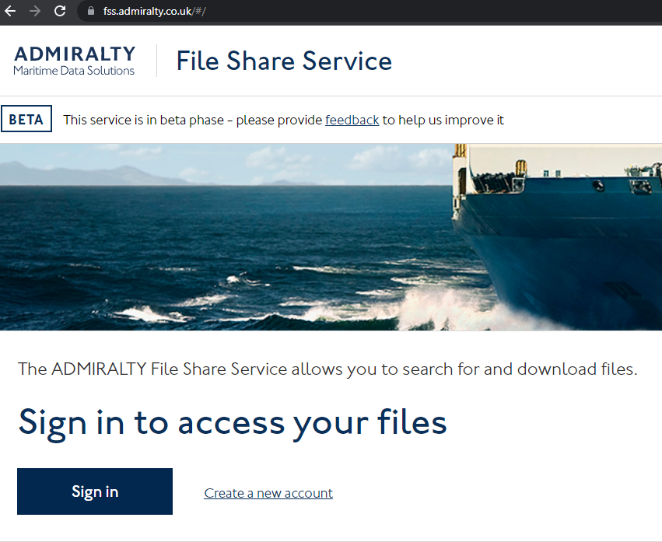

Users will need to have already created a Single Sign On (SSO) account.

(If not, they can use the ‘Create a new account’ link to create their SSO account)

Click ‘Sign In’ enter your email click ‘Continue’ then enter your password if prompted and then ‘Sign in’ You should now see the below screen

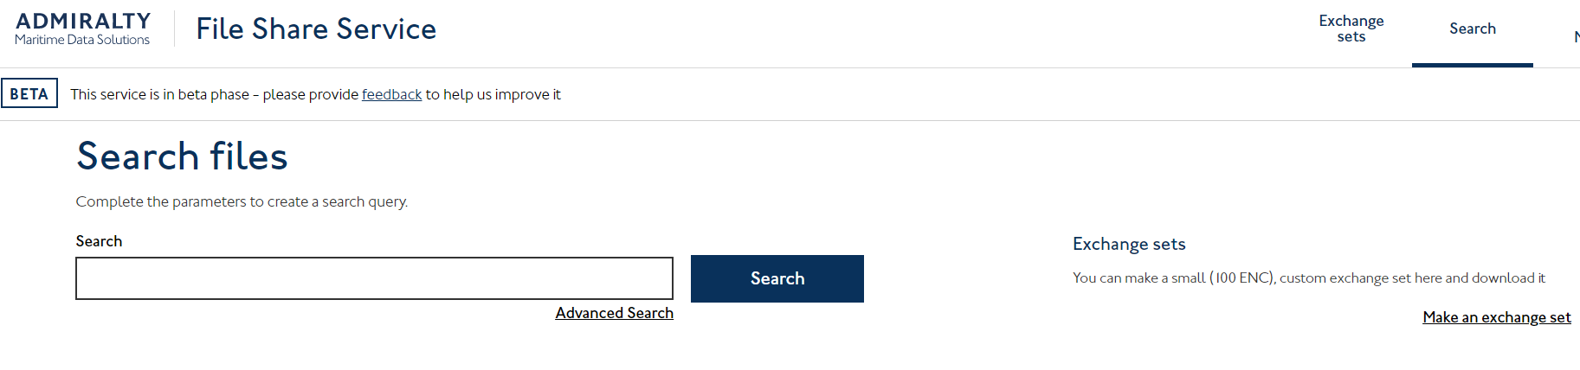

At the top right of the screen click Exchange sets

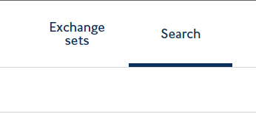

This will take you to Exchange Sets UI and you will see the options *‘Download all data’ or ‘Download updates’*

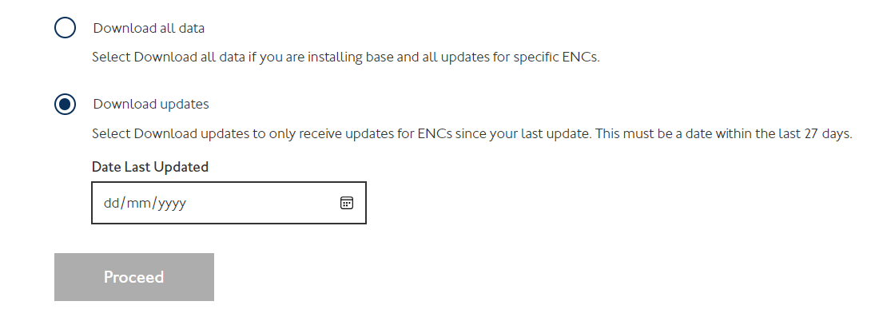

Here you can choose to

1. ‘Download all data’ – This option provides all base data and updates for ENCs
2. ‘Download updates’ – This option allows to select a date within the past and return any missing updates to ENCs since the date you specified (must be a date within the last 27 days)

Select the option best meets you needs and click ‘Proceed’

This will take you to ‘Selecting ENCs’ screen and you will see the options *‘Upload a list in a file’ and ‘Add ENCs’*

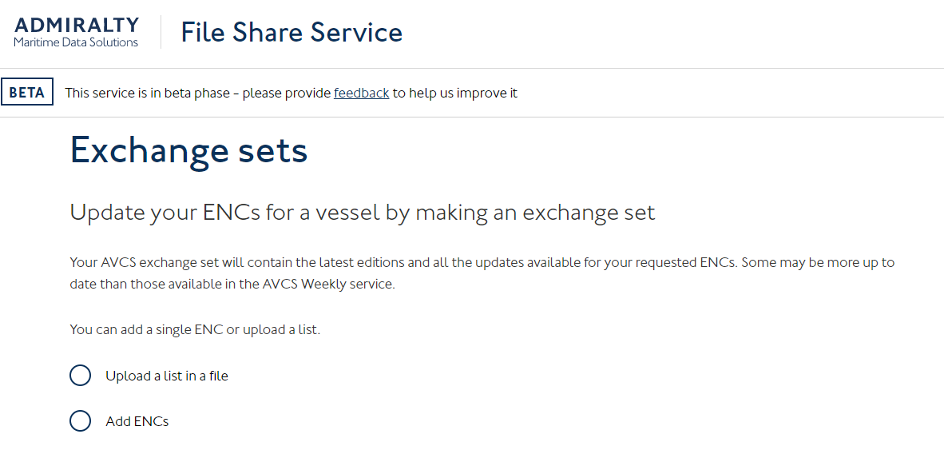

Users can then select which option they wish to use

1. Option *‘Upload a list file’* – this option allows Users to upload a PERMIT.TXT or .csv file

Users choosing this option will then see the below

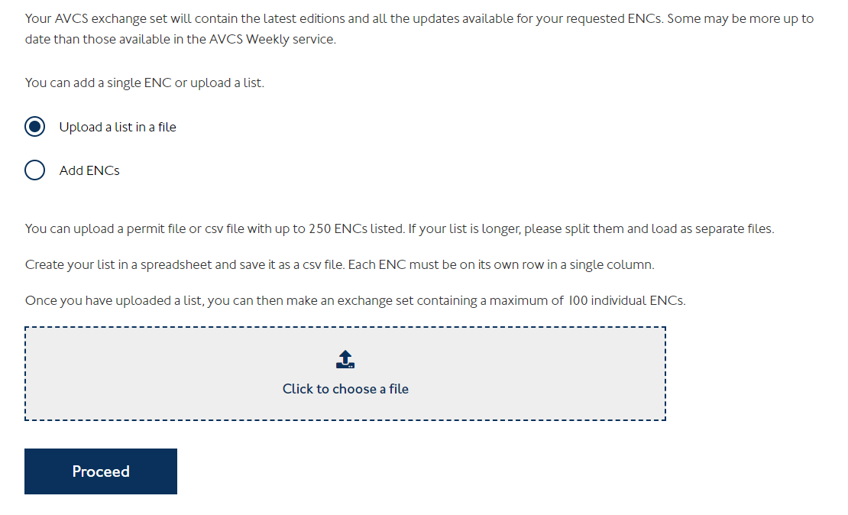

Ensure the PERMIT.txt file / .csv file is saved to a location on your PC, Select *‘Click to choose a file’* then navigate to and select the required PERMIT.txt file / .csv (alternatively you can drag and drop the file from the location to the *‘Click to choose a file’ tile)*

Click *‘Open’* or you can double click on the PERMIT.txt file / .csv you wish to load.

You should now see the PERMIT.txt file / .csv has been selected

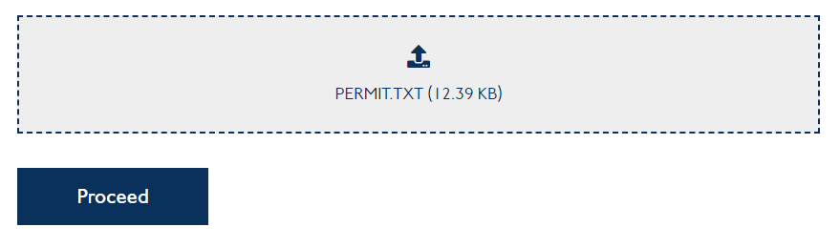

Click *‘Proceed’*

Users will then be presented with a list of ENCs under the *‘Your ENCs’* section from the loaded PERMIT.txt file / .csv, Users can then select the tick box under Choose, this will add the corresponding ENC to *‘Your selection’*

(User can add a maximum of 250 ENCs to any one request)

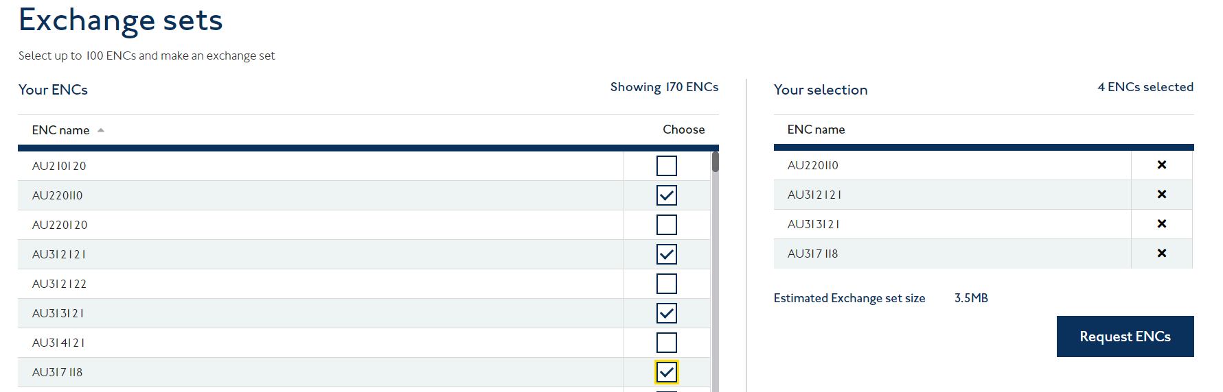

Once Users have added the required ENC(s) click *‘Request ENCs’* in the ‘Exchange set download’ window you will see the loading green icon and to the right of the screen a breakdown of the number of ENCs selected / included along with estimated request size.

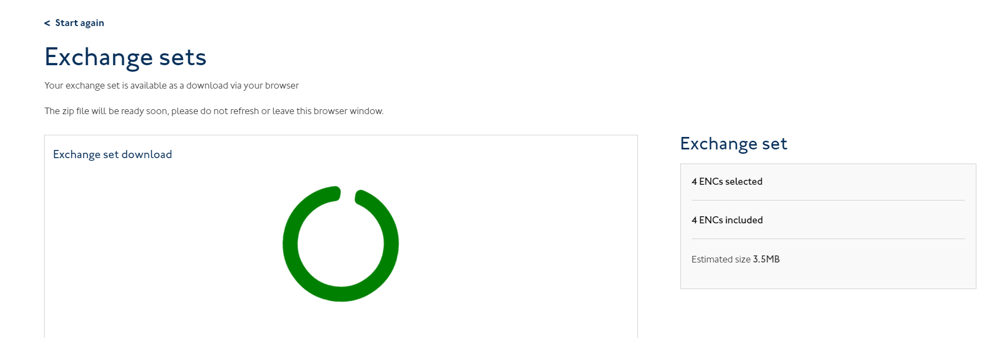

Once the Exchange set has been downloaded Users will see under ‘Exchange set download’ a ‘Download’ button

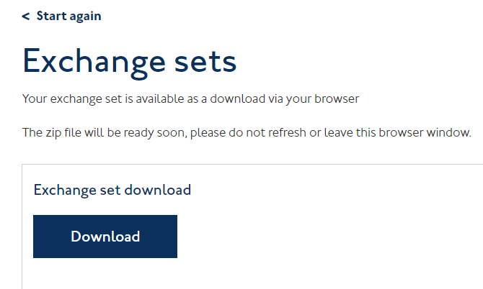

Click Download and the exchange set will be downloaded in your browser to your default download location (see example of this when using the Edge browser)

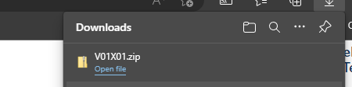

This can then be taken to vessels ECDIS for loading via the process outlined in their ECDIS Manual.

1. Option ‘Add ENCs’ – this option allows user to type in specific ENC number

Users choosing this option will see the below

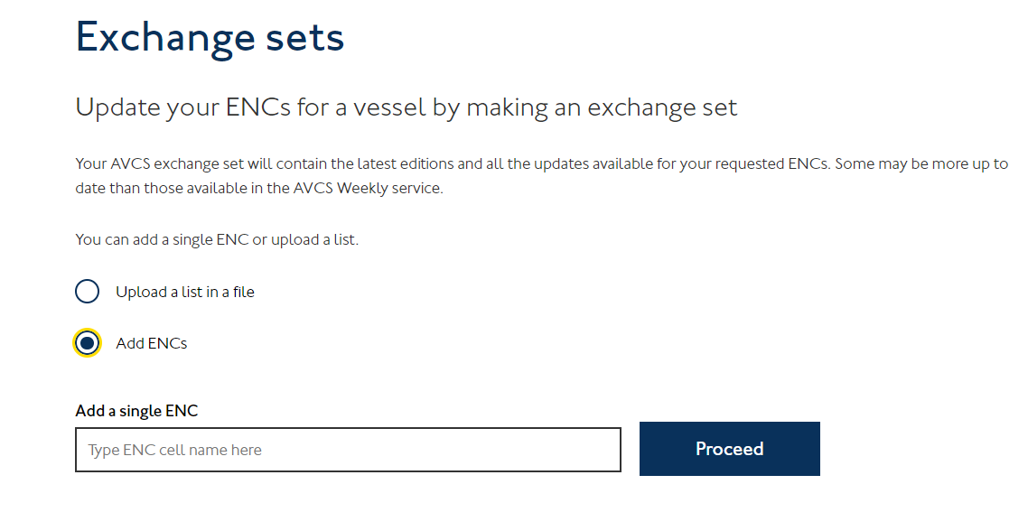

Type the ENC number you require and click ‘Proceed’

You will see under ‘Your ENCs’ the ENC you have entered

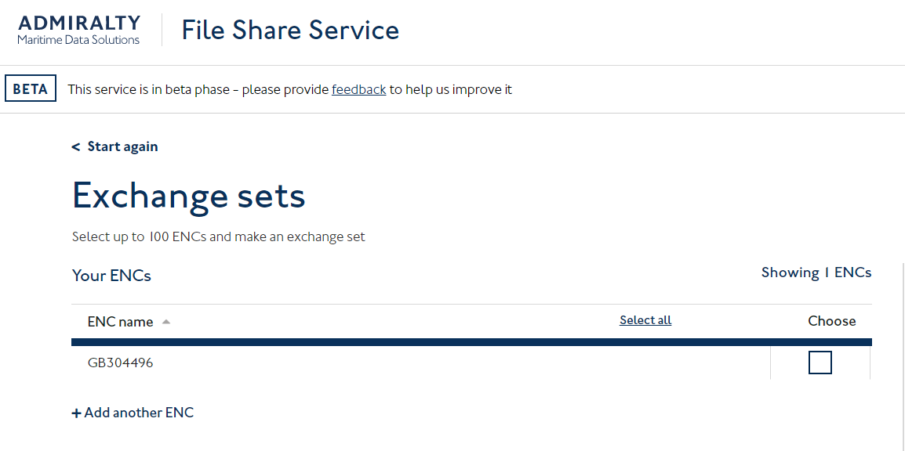

At this point you can either click *‘+ Add another ENC’* to add any further ENCs or select the tick box under Choose, this will add the corresponding ENC to *‘Your selection’*

(User can add a maximum of 250 ENCs to any one request)

Once Users have added the required ENC(s) click *‘Request ENCs’* in the ‘Exchange set download’ window you will see the loading green icon and to the right of the screen a breakdown of the number of ENCs selected / included along with estimated request size.



Once the Exchange set has been downloaded Users will see under ‘Exchange set download’ a ‘Download’ button



Click Download and the exchange set will be downloaded in your browser to your default download location (see example of this when using the Edge browser)



This can then be taken to vessels ECDIS for loading via the process outlined in their ECDIS Manual.

**NOTE :** If Users experience issues using the Exchange Sets function within the File Share Service, please provide the following details

1. Users email address that is being used to login to the File Share Service website
2. Is the User loading a PERMIT.TXT or CSV file (if so, please provide the Permit or csv)
3. If the User is trying to request a single ENC provide the ENC details
4. Provide a brief description of the process being followed and advise at what point they encounter an issue (screenshots of the process would be useful)
5. Provide a screenshot of the error(s)