1. The yellow pencil icon denotes an item which has changed. The yellow icon will stay until the object is next viewed, then will disappear. This displays the last 6 updates within the area it covers.
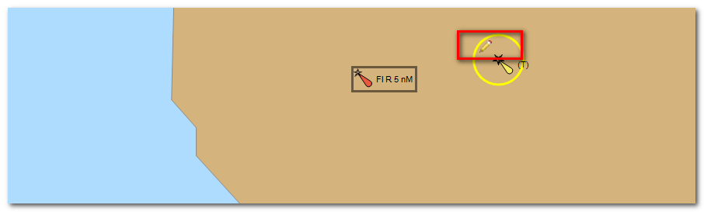
A full explanation is available in the product Help files.
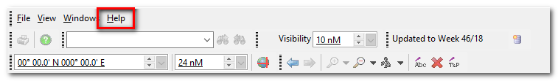
The position of the pencil also has significance where there is a hierarchy of objects. A pencil at the bottom right (circled in blue) means that less significant features have changed, a pencil at the top left (circled in red) means that the object itself has changed and both pencils (circled in green) means that the object and features have changed.
2. It is also possible to view the updates applied in certain weeks using the 'Properties' Window for a particular object.

3. Deleted objects can also be viewed by clicking on the red cross icon on the menu bar.
